OPERATING SYSTEMS
PRACTICAL-01
NAME : CHERUKUMALLI VIVEK
ROLL NO : 2520030532
SECTION -07

O/P
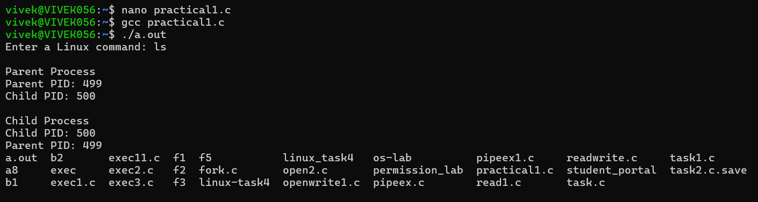

>Using Linux terminal commands (uname, lscpu, lsblk, ps, top), investigate the relationship between hardware resources and operating system services. Prepare a report explaining how the OS abstracts CPU, memory, storage, and I/O devices.
-uname
-lscpu
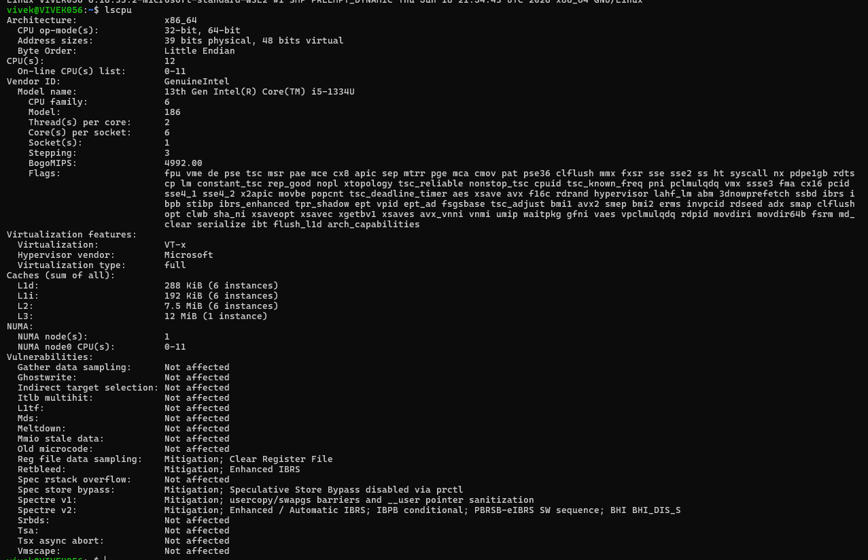
-lsblk
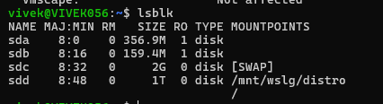
-ps
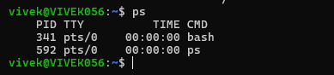
-top

